EXERCISE 5 - JEAN RAVEN MAGALING

- List all employees who hold the titles of “Senior Programmer” and “Multimedia Programmer”.
SELECT f_name, l_name, title
FROM employee_data
WHERE title IN ('Senior Programmer', 'Multimedia Programmer');

- List all employee names with salaries between $70,000 and $90,000.
SELECT f_name, l_name, salary
FROM employee_data
WHERE salary BETWEEN 70000 AND 90000;
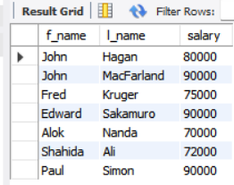
- What will the following statement display?
SELECT f_name, l_name, title
FROM employee_data
WHERE title NOT IN ('Programmer', 'Senior Programmer', 'Multimedia Programmer');
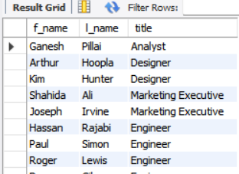
It will display:
- First name
- Last name
- Title
For all employees whose title is NOT ANY of the following:
- Programmer
- Senior Programmer
- Multimedia Programmer

- A complex statement combining IN + NOT BETWEEN. What will it display?
SELECT f_name, l_name, title, age
FROM employee_data
WHERE title NOT IN
('Programmer', 'Senior Programmer', 'Multimedia Programmer')
AND age NOT BETWEEN 28 AND 32;

Breakdown:
Condition 1:
title NOT IN (...)
→ employee must NOT be any kind of programmer.
Condition 2:
age NOT BETWEEN 28 AND 32
→ employee must be either younger than 28 OR older than 32
(because NOT BETWEEN excludes the whole range).

